QUESTION 4

**PAC CHART:**

|  |  |
| --- | --- |
| **Problem** | Determine if given 5 card is poker hand Full House (3 of one rank and 2 of another). |
| **Algorithm** | Check if any rank has 3 occurrences and another has 2 occurrences. |
| **Constraints** | Input exactly 5 integers (1 to 13). Only standard constructs allowed. |
| **Output** | Display whether the hand is a Full House or not. |

**IPO CHART:**

|  |  |
| --- | --- |
| Input | Five integers represent ranks of the poker cards. |
| Process | Count the occurrences of each rank, check for one rank with three cards and another with two cards. |
| Output | Display stating if the hand is a Full House or not. |

**ALGORITHM:**

1. Start
2. DECLARE 5 cards as numbers
3. Enter 5 integers for the poker hand
4. Check cards individually like cardnumber1 = cardnumber2 AND cardnumber2 = cardnumber3 AND cardnumber4 = cardnumber5 AND cardnumber1 <> cardnumber4 (For all types of situation)
5. If the condition gets true
6. Print House is full
7. Stop

# 

# 

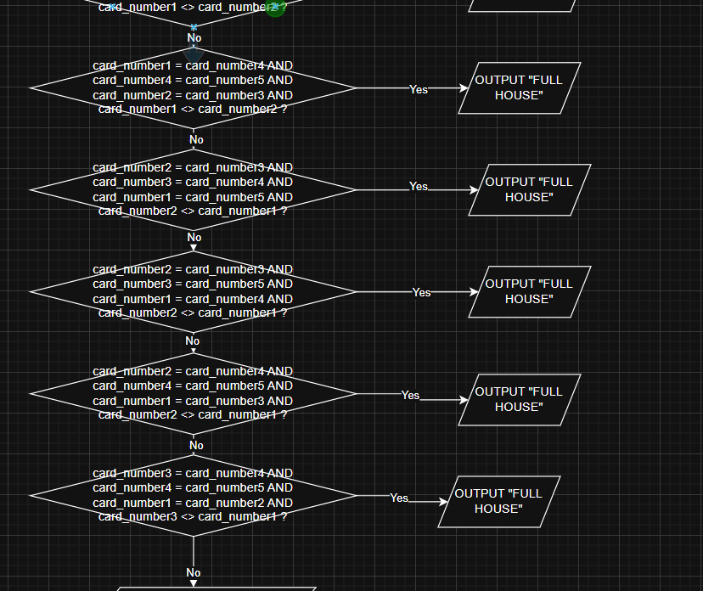

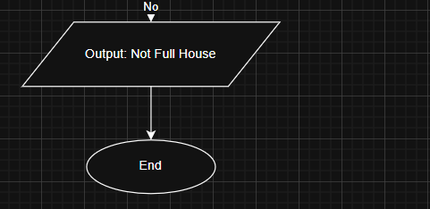

# Pseudocode:

DECLARE card_number1, card_number2, card_number3, card_number4, card_number5 AS INTEGER

OUTPUT "Enter Card number 1 (Between 1-13): "

INPUT card_number1

OUTPUT "Enter Card number 2 (Between 1-13): "

INPUT card_number2

OUTPUT "Enter Card number 3 (Between 1-13): "

INPUT card_number3

OUTPUT "Enter Card number 4 (Between 1-13): "

INPUT card_number4

OUTPUT "Enter Card number 5 (Between 1-13): "

INPUT card_number5

IF card_number1 = card_number2 AND card_number2 = card_number3 AND card_number4 = card_number5 AND card_number1 <> card_number4 THEN

OUTPUT "Full House"

ELSE IF card_number1 = card_number2 AND card_number2 = card_number4 AND card_number3 = card_number5 AND card_number1 <> card_number3 THEN

OUTPUT "Full House"

ELSE IF card_number1 = card_number2 AND card_number2 = card_number5 AND card_number3 = card_number4 AND card_number1 <> card_number3 THEN

OUTPUT "Full House"

ELSE IF card_number1 = card_number3 AND card_number3 = card_number4 AND card_number2 = card_number5 AND card_number1 <> card_number2 THEN

OUTPUT "Full House"

ELSE IF card_number1 = card_number3 AND card_number3 = card_number5 AND card_number2 = card_number4 AND card_number1 <> card_number2 THEN

OUTPUT "Full House"

ELSE IF card_number1 = card_number4 AND card_number4 = card_number5 AND card_number2 = card_number3 AND card_number1 <> card_number2 THEN

OUTPUT "Full House"

ELSE IF card_number2 = card_number3 AND card_number3 = card_number4 AND card_number1 = card_number5 AND card_number2 <> card_number1 THEN

OUTPUT "Full House"

ELSE IF card_number2 = card_number3 AND card_number3 = card_number5 AND card_number1 = card_number4 AND card_number2 <> card_number1 THEN

OUTPUT "Full House"

ELSE IF card_number2 = card_number4 AND card_number4 = card_number5 AND card_number1 = card_number3 AND card_number2 <> card_number1 THEN

OUTPUT "Full House"

ELSE IF card_number3 = card_number4 AND card_number4 = card_number5 AND card_number1 = card_number2 AND card_number3 <> card_number1 THEN

OUTPUT "Full House"

ELSE

OUTPUT "Not Full House"

END IF

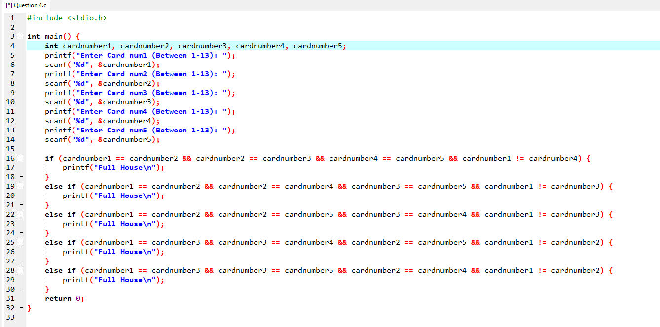**C CODE:**

